Moons of the Land - Teacher Exemplar
Grade 5/6 Arts Education - an example of the finished watercolour series students create
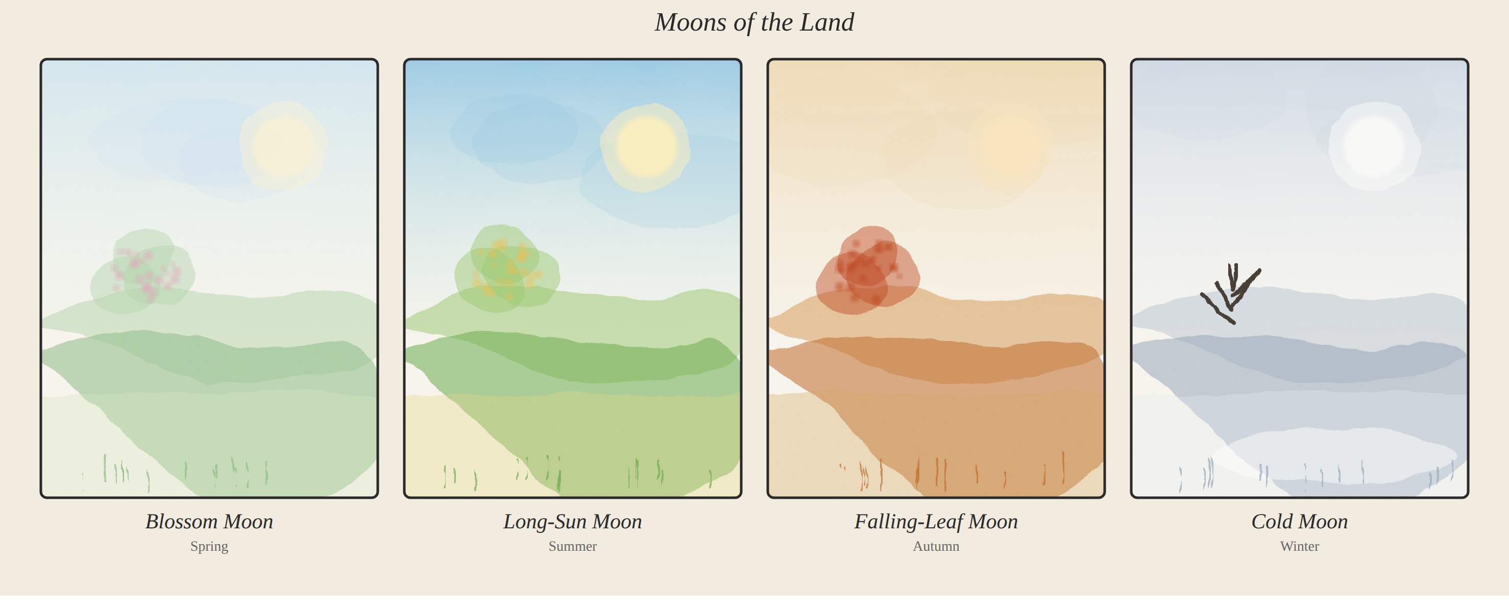
How to read this exemplar
This is one original watercolour series of four seasonal panels. The moon names are the student-artist's OWN names for what happens on the land where they live. It is a model, not a template: students learn from and honour the idea of the thirteen moons, then observe their own seasons and name their own moons. We do not copy a nation's calendar, sacred names, or imagery.
Model artist statement (what a student might write)
"My series shows the four seasons of the valley where I live. I named my moons for what I notice: the Blossom Moon when the fruit trees flower, the Long-Sun Moon of hot summer days, the Falling-Leaf Moon of autumn, and the Cold Moon of winter. I used a graded wash for each sky, wet-on-wet for the soft moons, and layering to build the hills. I kept a matching soft style so the four panels look like one series."
Moon key (this artist's choices)
Moon (season) | What it shows on the land
Blossom Moon (Spring) | Fruit trees flower and the land turns green
Long-Sun Moon (Summer) | Long, warm days and full green hills
Falling-Leaf Moon (Autumn) | Leaves turn red and orange; harvest time
Cold Moon (Winter) | Bare trees, snow, and a quiet land

Techniques shown: graded washes (skies), wet-on-wet (soft moons and sky blooms), layering (hills and depth), lifting (highlights), dry brush (grasses), a seasonal palette for each panel, and one shared style that unifies the series.

